QUITMAN CITY COUNCIL
Regular Meeting Agenda
Wednesday December 3, 2025
6:30 PM
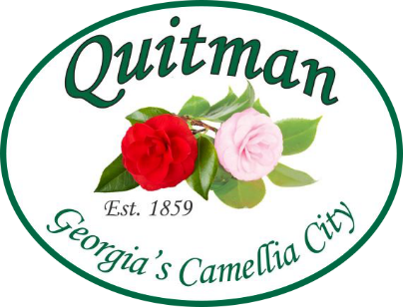
City Council:
Mayor Zinda McDaniel
Mayor Pro Tem Lula Smart
Council Member Kechia Harrison
Council Member Donald Morgan
Council Member Mattie Neloms
city officials:
City Manager Willie Burns
City Clerk Tabatha Fowler
Attorney Karla Walker
Chief of Police Lawrence McGee
Fire Chief Anthony Guarino
- CALL TO ORDER
- INVOCATION
- PLEDGE OF ALLEGIANCE
- ADOPTION OF AGENDA
- APPROVAL OF MEETING MINUTES
November 18, 2025, Regular Meeting Minutes

- MAYORS REPORT
- CITY MANAGER REPORT
- OPEN TO THE PUBLIC
- EXECUTIVE SESSION
- ADJOURN

