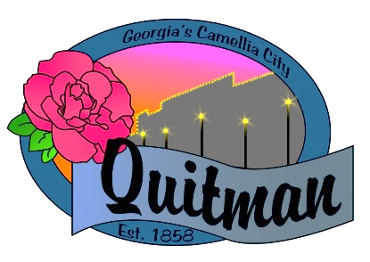
QUITMAN CITY COUNCIL

CALLED COUNCIL MEETING

Councilmembers:

Zinda McDaniel, Mayor
Mark DeVane, Mayor Pro -Tem
Mattie Neloms
Donald Morgan
Lula Smart

Tuesday, January 24, 2023
6:30 P.M.

QUITMAN CITY COUNCIL
CALLED MEETING MINUTES
Tuesday January 24, 2023
6:30P.M.

- CALL TO ORDER
The meeting was called to order by Mayor Zinda McDaniel at 6:30 PM, with Council members Smart, Morgan, Neloms and DeVane present. City Manager Maddox, City Attorney Karla Walker and City Clerk Lola Slydell was also in attendance.

- INVOCATION
Led by Fire Chief Floyd Demps

- PLEDGE OF ALLEGIANCE
Led by Mayor Zinda McDaniel

- ADOPTION OF AGENDA
Upon motion by Mattie Neloms and second by Donald Morgan s to adopt the agenda. Voting Yes. (Neloms, Morgan, Smart, DeVane).

- EXECUTIVE SESSION Pursuant to (OCGA 50-14-(6)).
Upon motion by Mattie Neloms and second by Mark DeVane to enter into executive session at 6:33 P.M.
Voting Yes. (Neloms, Morgan, Smart, DeVane).

Time out 7:01 P.M. motion by Donald Morgan second by Lula Smart was approved.
Voting Yes- (Neloms, Smart, DeVane, Morgan).

Consult with city attorney Karla Walker about pending ESG contract and Termination of Waste Management contract. Attorney Walker provided Council with updates.

- DISCUSSION OF ESG CONTRACT
Upon motion by Mattie Neloms and second by Mark DeVane to approve ESG contract as presented.
Voting Yes. (Neloms, Morgan, Smart, DeVane).

- DISCUSSION OF CIVILITY RESOLUTION 335-23
City Manager Raphel D. Maddox explained to council about the new civility resolution which represents pledging to practice and promote civility in decision making within the City of Quitman. Civility is more than just politeness. It is about disagreeing without disrespect, seeking common ground as a starting point for a dialogue about differences, listening past one's preconceptions and teaching others to do the same. Civility is the hard work of staying present even with those with whom we have deep-rooted and fierce disagreements.
Upon motion by Donald Morgan and second by Lula Smart to adopt resolution 335-23 pledging to practice and promote civility in the city of Quitman. Voting Yes. (Neloms, Morgan, Smart, DeVane).

- CITY NANGERS REPORT
Raphel D. Maddox updated council on the status of the 3yr contract for the Fire Department and is
awaiting final approval.

- DISCUSSION OF WASTE MANAGEMENT CONTRACT
City Attorney Karla Walker advised council on current status on Waste Management contract. Upon motion by Donald Morgan and second by Lula Smart to table item till next meeting. Voting Yes. (Neloms, Morgan, Smart, DeVane).

- ADJOURN
Motion by Donald Morgan and second by Lula Smart to adjourn at 7:12 P.M. was approved.
Voting Yes. (Smart, Morgan, DeVane, Neloms).

________________________________ _____________________________
Mayor, Zinda Mcdaniel City Clerk, Lola Slydell

_______________________
Date minutes approved

