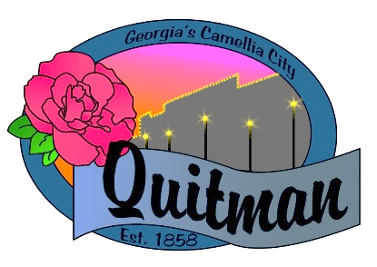
QUITMAN CITY COUNCIL

CALLED MEETING

Councilmembers:

Zinda McDaniel, Mayor
Mark DeVane, Mayor Pro -Tem
Mattie Neloms
Donald Morgan
Lula Smart

Tuesday, March 10, 2022
6:30 P.M.
With Zoom accessibility to the public

QUITMAN CITY COUNCIL
CALLED MEETING (ZOOM)
MINUTES
Tuesday March 10, 2022
6:30P.M.

- CALL TO ORDER
The meeting was called to order by Mayor Zinda McDaniel at 6:43 P.M, with Council members Smart, Morgan, Neloms and DeVane present. City Manager Maddox, City Attorney Karla Walker and City Clerk Lola Slydell was also in attendance.

- ADOPTION OF AGENDA
Upon motion by Mark DeVane and second by Lula Smart to adopt the agenda. Voting Yes. (Neloms, Morgan, Smart, DeVane).

- DISCUSS/APPROVE ALCOHOL ORDINANCE 606-21 PACKAGE OF SALE OF DISTILLED SPIRITS
Updates and changes to Alcohol Ordinance was discussed with the council by City Attorney Karla Walker. Upon motion by Lula Smart and second by Mattie Neloms to adopt changes made to Ordinance 606-21. Voting Yes (Smart, Morgan, DeVane, Neloms).

- ADJOURN
Motion by Mattie Neloms second by Lula Smart to adjourn at 7:25 P.M. was approved.
Voting Yes. (Smart, Morgan, DeVane, Neloms).

