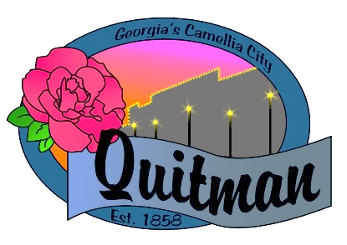
QUITMAN CITY COUNCIL

CALLED MEETING

Councilmembers:

Zinda McDaniel, Mayor
Mark DeVane, Mayor Pro -Tem
Mattie Neloms
Donald Morgan
Lula Smart

Tuesday, March 3, 2022
6:30 P.M.
With Zoom accessibility to the public

QUITMAN CITY COUNCIL
CALLED MEETING
MINUTES
Tuesday March 3, 2022
6:30 P.M.

- CALL TO ORDER
The meeting was called to order by Mayor Zinda McDaniel at 6:34 PM, with Council members Smart, Morgan, Neloms and DeVane present. City Manager Maddox, City Attorney Karla Walker and City Clerk Lola Slydell was also in attendance.

- ADOPTION OF AGENDA
Upon motion by Lula Smart and second by Mattie Neloms to adopt the agenda. Voting Yes. (Neloms, Morgan, Smart, DeVane).

- DISCUSS OF LIQUOR LICENSE ORDINANCE
Discussion was opened by City Attorney Karla Walker who presented to the Council a draft version of the City of Quitman Alcohol Ordinance that needed to be reviewed. All sections of the ordinance were read aloud and discussed. The application process, zoning and building requirements were some of the areas that were discussed in detail. Any areas where changes needed to be made will be completed by the City Attorney. Final draft of the Alcohol Ordinance will be presented later. No Action Taken.

- ADJOURN
Motion by Lula Smart second by Mattie Neloms to adjourn at 7:35 P.M. was approved.
Voting Yes. (Smart, Morgan, DeVane, Neloms).

