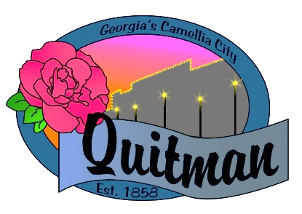
QUITMAN CITY COUNCIL

CALLED MEETING

Councilmembers:

Zinda McDaniel, Mayor
Mark DeVane, Mayor Pro -Tem
Mattie Neloms
Donald Morgan
Lula Smart

Tuesday, March 8, 2022
6:30 P.M.
With Zoom accessibility to the public

QUITMAN CITY COUNCIL
CALLED MEETING
MINUTES
Tuesday March 8, 2022
6:30P.M.

- CALL TO ORDER
The meeting was called to order by Mayor Zinda McDaniel at 6:46 PM, with Council members Smart, Morgan, Neloms and DeVane present. City Manager Maddox, City Attorney Karla Walker and City Clerk Lola Slydell was also in attendance.

- ADOPTION OF AGENDA
Upon motion by Donald Morgan and second by Mattie Neloms to adopt the agenda. Voting Yes. (Neloms, Morgan, Smart, DeVane).

- DISCUSS ALCOHOL ORDINANCE FOR PACKAGE SALE OF DISTILLED SPIRITS & RESOLUTION 327-22
Discussion was opened up by City Clerk Lola Slydell first addressing the Quota Application Process for Licensing to sell packaged liquor. Dates selected for the acceptance of applications will begin March 11, 2022, and Close March 25, 2022. Once all applications are reviewed, the City Clerk will contact all applicants to update the status of them on or before April 1, 2022. The Quota drawing shall be conducted on April 12, 2022 @ 4:00 pm at City Hall Meeting Room located at 100 W. Screven St. Drawing will also be live streamed via ZOOM or other similar source. Those selected will make application to the City Clerk for a retail package store license no later than April 25, 2022. Upon Motion by Donald Morgan and second by Mattie Neloms to accept dates for resolution 327-22.

- ADJOURN
Motion by Lula Smart second by Mattie Neloms to adjourn at 6:54 P.M. was approved.
Voting Yes. (Smart, Morgan, DeVane, Neloms).

