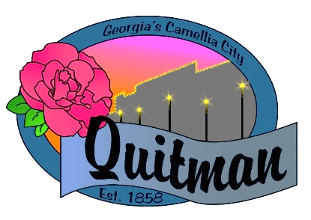
QUITMAN CITY COUNCIL

CALLED MEETING

Councilmembers:

Zinda McDaniel, Mayor
Mark DeVane, Mayor Pro -Tem
Mattie Neloms
Donald Morgan
Lula Smart

Wednesday, June 29, 2022
6:15 P.M.
Zoom Video Conference
with Zoom accessibility to the public

QUITMAN CITY COUNCIL
CALLED MEETING MINUTES
Wednesday, June 29, 2022
6:15 P.M.

- CALL TO ORDER
The meeting was called to order by Mayor Zinda McDaniel at 6:26 pm, council members Smart, Neloms, Morgan and DeVane present. City Manager Raphel D. Maddox and City Clerk Lola Slydell was also in attendance. The meeting was conducted via video zoom with accessibility to the public.

- ADOPTION OF AGENDA
Upon the motion by Donald Morgan and a second by Mattie Neloms the agenda was approved. Voting yes (Neloms, Morgan, Smart, DeVane).

- DISCUSSION OF CARTERS QUITMAN, LLC- Business License Request
Upon the motion by Donald Morgan and second by Mattie Neloms to approve business license request for Carter’s Quitman LLC. Voting yes (Neloms, Morgan, Smart, DeVane).

- DISCUSSION OF NEW LANE NAME- Mobile Home Placement Request – Binny Odum
Council agreed to allow Mr. Binny Odum to choose between Gunny Lane and Odum Lane. No Action Taken.

- ADJOURN
Motion by Lula Smart and second by Mattie Neloms to adjourn at 6:42 P.M. was approved.
Voting Yes- (Neloms, DeVane, Smart, Morgan).

