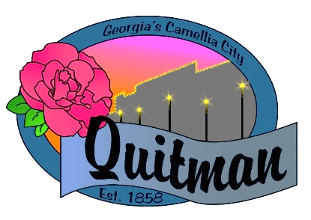
QUITMAN CITY COUNCIL

CALLED MEETING

Councilmembers:

Zinda McDaniel, Mayor
Mark DeVane, Mayor Pro -Tem
Mattie Neloms
Donald Morgan
Lula Smart

Tuesday, July 11, 2022
6:30P.M.
Zoom Video Conference
with Zoom accessibility to the public

QUITMAN CITY COUNCIL
CALLED MEETING MINUTES
Tuesday July 11, 2022
6:30 P.M.

- CALL TO ORDER
The meeting was called to order by Mayor Zinda McDaniel at 7:31 pm, council members Smart, Neloms, Morgan and DeVane present. City Manager Raphel D. Maddox and City Clerk Lola Slydell was also in attendance. The meeting was conducted via video zoom with accessibility to the public.

- ADOPTION OF AGENDA
Upon motion by Donald Morgan and second by Lula Smart to adopt the Agenda Voting yes
(Neloms, Morgan, Smart, DeVane).

- DISCUSSION OF BEER & WINE LICENSE- Family Dollar
Mayor Pro-Tem Mark DeVane expressed his concern on Family Dollar meeting proper distance requirements to proceed in approving beer & wine license for Family Dollar.
City Manager Raphel D. Maddox discussed with the council about having all businesses who sell alcohol to require its employees to wear a badge (servers license) that shows that they are legal/trained to sell alcohol. Discussion on alcohol ordinance and process will be researched by City Attorney for further consideration. Upon motion by Donald Morgan and second by Lula Smart to approve the Beer & Wine request from Family Dollar. Voting yes (Neloms, Morgan, Smart, DeVane).

- DISCUSSION OF WASTE MANAGEMENT CONTRACT
City Manager Raphel D. Maddox discussed with the council on the current terms agreed for services from Waste Management. Some of the changes discussed were waste management discontinuing its yard waste services (limbs/leaves) and a possible $1 increase in trash services. Mayor Pro-Tem Mark DeVane added that since services was projected to increase anyway this seemed to be a decent solution for continued services from Waste Management. Upon motion by Mark DeVane and second by Donald Morgan to accept current terms of the Waste management Agreement. Voting yes (Neloms, Morgan, Smart, DeVane).

- DISCUSSION OF MORATORIUM
City Attorney Karla Walker discussed with council about the different type of moratorium requests and wanted direction from council on the direction they wanted to go. She advised them on putting in place a specific guideline for the moratorium and would follow-up with council on her findings and other suggestions before approval. City Manager Raphel D. Maddox advised to apply moratorium to entire City once approved. No Action Taken.

- DISCUSSION OF TINY HOUSE ORDINANCE
City Attorney Karla Walker discussed with council or some ideas to consider for Tiny House ordinance. Item Tabled. No Action Taken.

- DISCUSSION OF ZONING MAP UPDATE
Mayor Zinda McDaniel updated council on changes that have already been made to the zoning map for the City of Quitman. She encouraged council to look at current changes before next workshop date so that they can make any necessary adjustment to the map if needed. Deadline to have current map viewed by is Aug 1, 2022. No Action Taken.

- DISCUSSION OF EMPLOYEE OF THE MONTH
City of Quitman recognized Derrick Sloan for Employee of the Month

- CITY MANAGER UPDATES
City Manager Raphel D. Maddox updated council on upcoming firefighter training as well as the current status of the audit.

- ADJOURN
Upon motion by Lula Smart and second by Mattie Neloms to adjourn at 7:52 pm. Voting yes (Neloms, Morgan, Smart, DeVane).

__________________________________ _______________________________
Zinda McDaniel, Mayor Lola Slydell, City Clerk

______________
Date minutes was approved

